Date: 31.01.2025
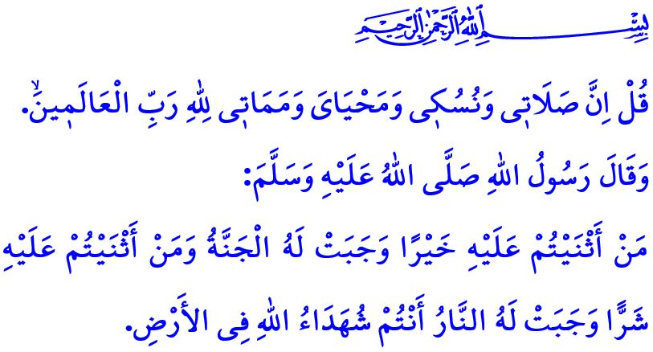
FAREWELL TO THE TRAVELER EN ROUTE TO ETERNITY
Dear Muslims!
According to our sublime religion, Islam, human beings are inherently valuable and deserving of honor and dignity, both in life and in death. Just as a newborn is washed, wrapped in swaddling clothes, carried in loving arms, and welcomed with the adhan, iqamah, and prayers, so too, upon death, a person is washed, shrouded, carried on the hands of others, and bid farewell with salas and prayers. Because death is not the end. It marks the beginning of eternal life. For a Muslim, death is the first stop on the journey toward the infinite blessings and rewards of Allah. It is the gateway to paradise. It is a blessed homecoming, where they will be reunited with their loved ones.
Dear Believers!
We have both religious and human duties to fulfill towards our deceased brothers and sisters. The first of these duties is to wash and shroud the deceased while maintaining respect for their dignity and privacy. Another duty of ours is to perform the funeral prayer for our brother or sister and then bid them farewell on their eternal journey with reverence and solemnity. The funeral prayer is performed with the men at the front and the women at the back. It is not in our religion to argue at the funeral, to send off the deceased with applause or music, or to decorate the prayer area with wreaths or icons. Another responsibility of ours is to ask Allah to forgive the sins of our deceased brother or sister, to pray for them, and to fulfill our duty of bearing testimony to them. Our Prophet (saw) emphasizes the importance of bearing testimony to the deeds of a deceased person by saying, “Whoever is praised will be granted Paradise, and whoever is criticized will be granted Hell, You are the witnesses of Allah on Earth.”
Dear Muslims!
It is a requirement of Islamic brotherhood to offer condolences to the relatives of the deceased, to wish them patience, to share in their sorrow, and to comfort their hearts with the recitation of the Holy Qur’an. However, there are also certain matters we should be mindful of when offering condolences. According to Islam, condolences should not extend beyond three days. It is not appropriate for the bereaved to incur great expense for the condolence or to prepare food for the guests. It is sunnah for the relatives and neighbors to offer food to the deceased’s family and guests during the days of condolence. For example, when the Messenger of Allah (saw) received the news that his uncle’s son, Ja‘far, had been martyred in the Battle of Mu‘tah, he said, “Prepare food for the family of Ja‘far...”
Esteemed Believers!
Unfortunately, we have become unable to reflect on death, which tarnishes the sweetness of life. We are gradually moving away from the funeral etiquette prescribed by our sublime religion, Islam. Some people may continue to have fun and enjoy themselves even when there is a funeral in their apartment block or street. Some people, in pursuit of higher ratings, repeatedly broadcast images of the deceased on television and digital media, exacerbating the grief of the bereaved. However, Muslims cannot remain indifferent to what is happening around them. They cannot ignore the pain of death and pretend that nothing has happened. They cannot speak or behave in a way that may cause further grief to the relatives of the deceased.
Dear Muslims!
Let us strive to bid farewell to our brothers and sisters who have passed into the eternal world on their final journey, in accordance with the teachings of Islam. Let us remember our deceased with fondness. On their behalf, let us give charity and perform good deeds to the best of our ability. Let us do works that will keep their names alive and continue to be a source of prayers for them. In this way, let us play a role in ensuring that the books of deeds of our relatives who have passed on to the Hereafter remain open and recording.
Next Thursday marks the second anniversary of the earthquake that affected eleven provinces. On this occasion, I pray for our Lord Almighty’s mercy for all our brothers and sisters who have passed away. May Allah the Almighty protect our country, our nation, and all of humanity from all kinds of disasters.
I would like to conclude this Friday’s khutbah with the following verse that explains the purpose of life and death: “Say, “Surely my prayer, my sacrifice, my life, and my death are all for Allah—Lord of all worlds.”

Muslim, Jana’iz, 60.
Tirmidhi, Jana’iz, 21.
An‘am, 6/162. General Directorate of Religious Services

